**AUGUST 2024**

MISSION STATEMENT

To assist the Developmentally Disabled and the Elderly Disabled to achieve community inclusion that enhances personal potential, employment opportunities and/or volunteerism.

Those Who Serve:

Don Cisco Amanda Barnum Karen Keezer Laura Lichy Carole Vicari Damika Ballard Tammy Gaertner Terry Prickett Kianna Wimberly Kelly O’Neill Ishah Aranda Emmanuel Edeani Suane Thomas  **Phillip Bullock**  Shantel Caldwell Nicole Berry LaShay Hurn Dawn Palumbo Nicole Radeback Windie Underwood

Breanna Toomey

Arkay Crossing

15221 Eureka Rd.

Southgate, MI 48195

Office: (734) 282-8055

Fax: (734) 282-7986

Executive Director: Kevin McGuckin

Director of Programs: Amanda Merritt

Email Us:

[arkay.crossings@miarkay.org](mailto:arkay.crossings@miarkay.org)

**\*\*AND CHECKOUT THE NEW REVAMPED WEBSITE AT:**

**Arkay Website: miarkay.org**

Like us on Facebook at [www.facebook.com/miarkay.org](http://www.facebook.com/miarkay.org)

[](http://www.google.com/url?sa=i&source=images&cd=&cad=rja&docid=2B69wRO_WTwuXM&tbnid=jQlxbk6pT4T8SM:&ved=0CAgQjRwwAA&url=http://magickalgraphics.com/getwellsoon4.htm&ei=8buPUuq3C6Pr2wXR_oHgDw&psig=AFQjCNHlJRrk_u_nztI4jS0ZiNqukBCqIw&ust=1385237873261727)

**Get Well Soon**

We wish all of our consumers, staff, and parents/caregivers who have been ill a speedy recovery. Our prayers go out to all of you.

[](http://www.google.com/url?sa=i&source=images&cd=&cad=rja&docid=FOSh5_ittbn5FM&tbnid=ItP6TnVU4OxMJM:&ved=0CAgQjRwwAA&url=http://nycprowler.com/2013/08/14/happy-birthday-song-costs-150000-bucks-would-you-pay-that-2/&ei=Ib2PUrCBLtG-2wXGyIGwDg&psig=AFQjCNEbNeXSz9HrIpnEdYNTP_zGjw2UjQ&ust=1385238177836306)

Happy Birthday

Amanda Barnett 8/10, Timothy Benjamin 8/14, Johnathon Swick 8/11, Erica Sonnenberg 8/11, John Atanosian 8/28, Kelsey Haddix 8/13, Scott Barclay 8/29, Caryn Cochren 8/2, Angie Skattie (Palazzolo) 8/26, Melissa Soubliere 8/17, Ashley Dangerfield 8/23, and Shawn Hill 8/12. We wish everyone a happy birthday!!!

[](http://www.google.com/url?sa=i&source=images&cd=&cad=rja&docid=i6xl7ac5QWUJHM&tbnid=RRH441LNgbJvjM:&ved=0CAgQjRwwAA&url=http://www.jakejunction.com/specialthanks.html&ei=TLyPUp_IHJKJ2AWb8YC4Bg&psig=AFQjCNEE8mkd5ViyfQ1w3Hm4QqU1g9wIcQ&ust=1385237964544564)

**Anniversary**

Shantel Caldwell 8/19/2019 Thank you for your dedication!!!

**Case Manager’s Corner**

**Amanda Barnum:** A – Johnson, Mazzara and Sabat **Carole Vicari:** JQ- R **Tammy Gaertner:** S- Z **LaShay Hurn**- Case Coordinator.

We are here to assist the individuals of Arkay, staff, caregivers, and the MCPN’s. Their outcomes, Accomplishments, and Success are only met with group effort.

\*\*\***Please remember we go out in the community daily so please do not bring anything that needs to be heated in your lunches. We do not have access to a microwave when out in the community. Also, please make sure that your people have an ice pack in their lunches to keep them cold. Thank You.\*\*\***

[](http://rds.yahoo.com/_ylt=A0WTb_zeULJL2xoAJwuJzbkF;_ylu=X3oDMTBpdnJhMHUzBHBvcwMxBHNlYwNzcgR2dGlkAw--/SIG=1k0drmlim/EXP=1270063710/**http:/images.search.yahoo.com/images/view?back=http://images.search.yahoo.com/search/images?p=van&b=1&ni=20&ei=utf-8&y=Search&xargs=0&pstart=1&fr=yfp-t-911&w=500&h=320&imgurl=www.ecarsavenue.com/wp-content/uploads/2009/09/iveco-daily.jpg&rurl=http://www.ecarsavenue.com/fiat-cars/fiat-thinking-of-two-vans-to-replace-the-sprinter&size=31k&name=Iveco+Daily&p=van&oid=34701b975dd400e6&fr2=&no=1&tt=64267201&b=1&ni=20&sigr=12mtfjnuo&sigi=11uj6hgm0&sigb=13c0h61)**VAN DRIVERS CORNER**

We would like to thank those who continue to donate their van transportation. **We would not be able to offer van transportation without donations**. We will be there to pick you up. If for any reason we must cancel van transportation we will call you as soon as possible. ***Your individual needs to be ready from 7:30-9:00a.m.***

**Business Developers Corner:**

It’s hard to believe that summer is almost over! Except for the rain, the Wyandotte Street Art Fair was a success. Thank you to everyone who came out to support Arkay and the Individuals we serve! We informed the community about all of the services Arkay offers in Wayne and Oakland counties. We also promoted our new Java Junction coffee house and sold Java Junction merchandise and bags of coffee.

Crossings is having a Flea Market on Saturday August 17th from 10am – 4:30pm. It is $15 per table or 2 tables for $25. Please call Jesse at 734-284-2929 if you’re interested in renting a table.

Your Arkay Business Development team: Kyra, Kim, Mark, Megan & Ken



**Just a reminder**: **ALL CHECKS MUST BE 7 DAYS BEFORE THE EVENT FOR PROCESSING TIME**.

***\*\*\*PLEASE MAKE SURE WHEN SIGNING UP FOR EVENTS TO DO SO AHEAD OF TIME. THERE IS A CUT OFF FOR ALL EVENTS LISTED IN THE NEWSLETTER OR AS SOON AS IT’S FILLED!!!*** 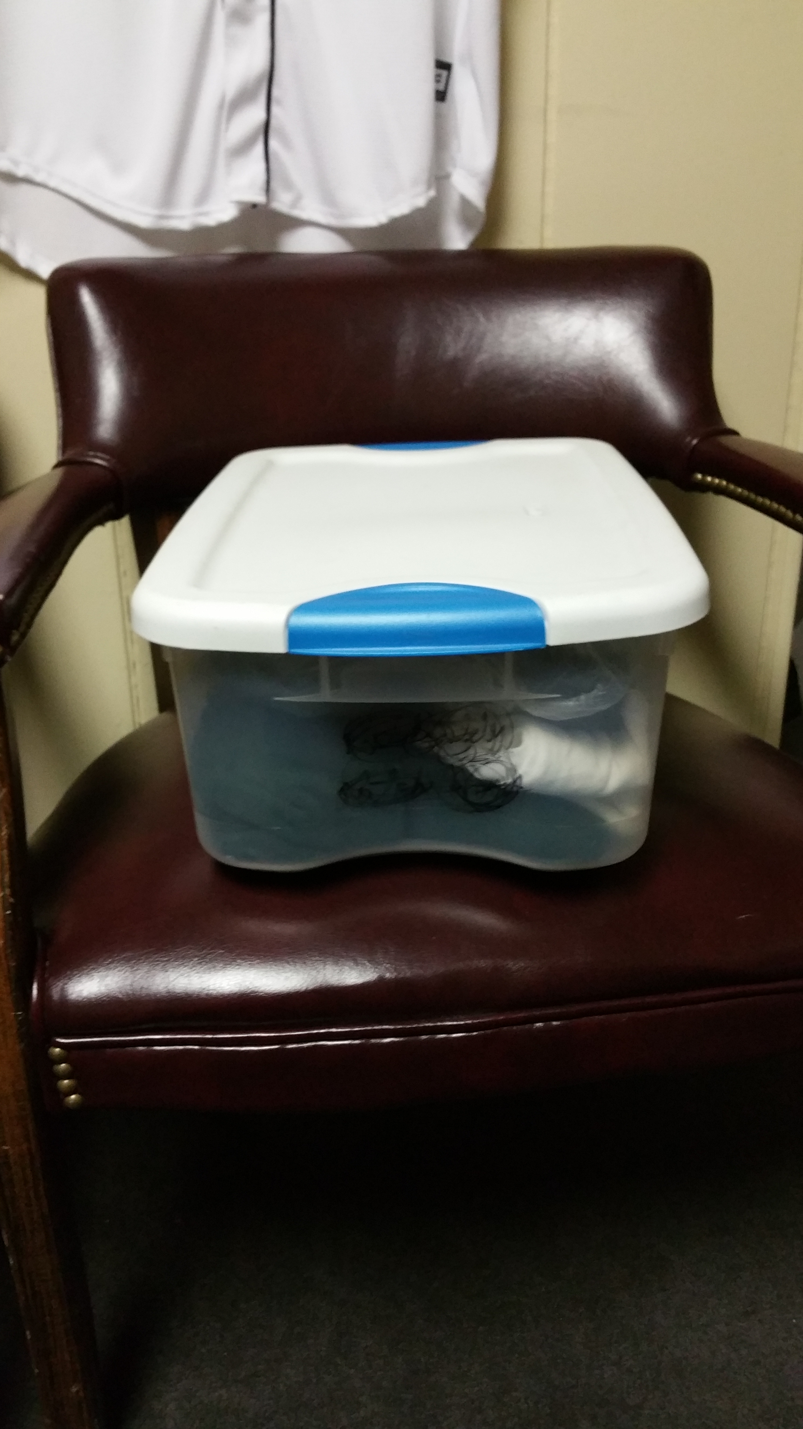

IF YOUR CONSUMER HAS CLOTHES THAT ARE KEPT HERE WE NEED YOU TO PURCHASE A TOTE JUST LIKE THIS CLEAR ONE AND GIVE IT TO US SO WE MAY PUT THEIR CLOTHES IN INDIVIDUAL BINS LABELED WITH THEIR NAME ON THEM. PLEASE DO THIS ASAP. THANK YOU FOR YOUR COOPERATION!!

ALL EVENTS ARE PAID INDIVIDUALLY, SO PLEASE HAVE CORRECT CHANGE and SMALL BILLS (IF POSSIBLE) FOR EACH ACTIVITY. We do not have access to change at all times!! Please give all activity money to Amanda. Thank you!!!

**WE OFFER SHREDDING SERVICES. IF YOU HAVE ANY DOCUMENTS THAT NEED TO BE SHREDDED, PLEASE LET US KNOW!!!**

**\*WE ACCEPT DONATIONS FOR: ANY KIND OF PARTY SUPPLIES (NAPKINS, PLATES, CUPS, SILVERWARE, POP, ETC.), CLEANING SUPPLIES, ETC.**  **THANK YOU IN ADVANCE FOR ALL OF YOUR SUPPORT!\***

**REMINDERS:**

**DUE TO THE WARMER WEATHER, PLEASE HAVE YOUR INDIVIDUAL BRING IN A WATER BOTTLE LABELED WITH THEIR NAMES ON IT.**

**ALSO, WHEN PACKING A LUNCH PLEASE INCLUDE AN ICEPACK TO ENSURE THE LUNCH STAYS FRESH.**

**WE ARE ALSO ASKING FOR DONATIONS OF CASES OF WATER TO KEEP OUR INDIVIDUALS HYDRATED.**

***MICRO BUSINESSES***

**Detroit Art by Chelsea Speagle**

**Hollywood’s Goods by LeeAnn Heasley**

**Paula’s Plastic Creations by Paula Kollar**

**Scarves by Kari by Kari Meininger**

**Reco’s Ice cream Shop by Reco Nash**

**Mr. Z’s Chocolate Treats by Haisam Zaban**

**Melissa's Munchies by Melissa Pike**

**Flower Pot Pens by Katie by Katie VanHamme**

**Erin’s Crazy Kitty Toyz and Crafts by Erin Spadafore**

**Be-you-tiful Bracelets By Jessica Hutchison**

**Kevin’s Corner**

I hope everyone is having a wonderful summer. It is hard to believe that it is August already. August is the eighth month of the year in the Julian and Gregorian calendars. Its length is 31 days. In the Southern Hemisphere, August is the seasonal equivalent of February in the Northern Hemisphere. In the Northern Hemisphere, August falls in the season of summer Did you know that it is named after Augustus Caesar, the first emperor of the Roman Empire?

Arkay seeks to expand its reach and its services. We have a new Strategic Plan which will map out the future of Arkay. We will continue to emphasize community integration with our services with full participation in community life: This requires full participation in community life. Our goal is to focus on integrated and unsubsidized employment for our customers.

Recently, we celebrated the 25th anniversary of the U.S. Supreme Court’s decision in [*Olmstead v. L.C*](https://www.olmsteadrights.org/about-olmstead/).,  a landmark case that opened the door for millions of people with disabilities to live in the community. The Olmstead case involved two women from Georgia, Lois Curtis (the L.C. in the case name) and Elaine Wilson, who both had diagnoses of intellectual disability and mental health conditions. Lois and Elaine were forced into the state’s mental health hospitals many times, despite wanting to remain at home with the help of community-based services. Doctors agreed that Lois and Elaine were capable of living in the community, with appropriate support. However, the state took years to set up their services. The Atlanta Legal Aid Society filed a lawsuit on behalf of Lois and later added Elaine to the case. Tommy Olmstead, Commissioner of the Georgia Department of Human Resources, was the defendant.  The case was grounded in the Americans with Disabilities Act (ADA) and whether people with disabilities could decide where they could receive services and supports. The Supreme Court issued a requirement that states had to eliminate unnecessary segregation of persons with disabilities and to ensure that persons with disabilities receive services in the most integrated setting appropriate to their needs.

The Supreme Court held that the ADA prohibits unjustified segregation of people with disabilities and that states must provide community-based services to people with disabilities when: such services are appropriate; the individuals do not oppose such services; and community-based services can be reasonably accommodated, considering governmental resources and the needs of others receiving disability services.

The Olmstead Decision is a living roadmap to help ensure that people with disabilities, including intellectual and developmental disabilities (IDD) receive the support they need and opportunities to live, work, and learn in the setting of their choosing.

Arkay will need to continue to emphasize community integration with supported employment and skill building services. This continues to be achieved through Arkay’ coffee & sandwich shop, Java Junction. Please visit Java for a tasty coffee & a delicious sandwich. Full participation in community life is the goal: All individuals are to be supported to take part in their community and have the same access as other individuals in the community. This requires full participation in community life. Arkay will need to emphasize & focus on integrated and unsubsidized employment for our consumers.

Best Regards,

Kevin McGuckin